**GIT Branching**

Name – Hritik Ray

Section - B

Objective: Commit HTML, CSS & JavaScript assignments into GIT.

1. **Create a new branch ‘css-assignments’.**



1. **Switch to ‘css-assignments’ branch.**



1. **Copy all CSS assignments inside ‘Assignments’ folder.**

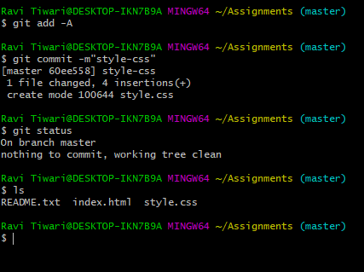

1. **Commit CSS assignments into ‘css-assignments’ branch.**

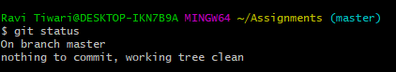

1. **Make minor changes into README.txt file on line 1 belonging to ‘css-assignments’ branch.**

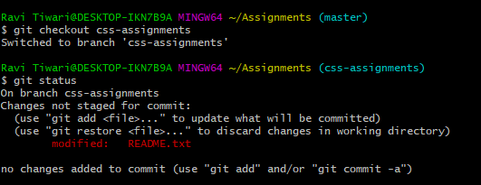

1. **Commit those changed files**

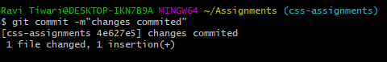

1. **Switch to master branch.**



1. **Make minor changes into README.txt file on line 3 & commit those changes into master.**

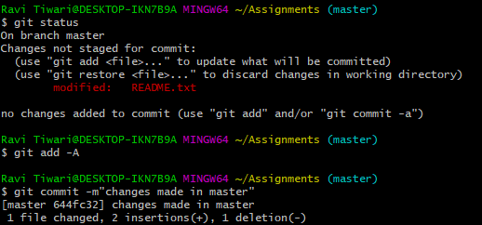

1. **Again switch to ‘css-assignments’ branch.**



1. **Make minor changes into few files belonging to ‘css-assignments’ branch.**

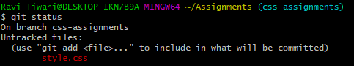

**Changes made in vscode**

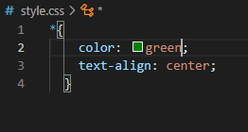

1. **Commit those changes**

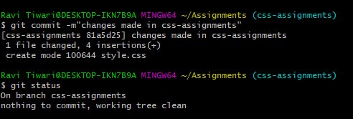

1. **Switch to master.**



1. **Merge ‘css-assignments’ branch into master. Confirm all css assignments are shown in master**

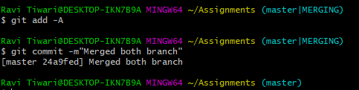

1. **Finally delete the ‘css-assignments’ branch.**

